POSTULATE BLOCK — SPATIAL & TEMPORAL DIMENSIONALITY (P-ST1)
Postulate ID: P-ST1 Postulate Class: Foundational Dimensionality Anchor Type: S (Structural) Method: Math/Obs Status: Candidate → Ready for threading into Master Equation Index Ledger

P-ST1 — Spatial–Temporal Dimensional Independence

Statement
Space consists of exactly three independent spatial dimensions:
(x, y, z)
The variable
r=(x^2+y^2+z^2)^1/2

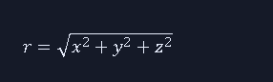
is a derived quantity, not a dimension. It introduces no additional degrees of freedom and is therefore redundant with respect to dimensionality.
Time consists of one independent temporal dimension:
t
Space and time are independent constructs. They do not form a geometric manifold, nor do they merge into a unified “spacetime fabric.” Their independence is structural and invariant.

P-ST1.1 — Motion Coupling Rule
Motion requires time. For any object moving at less than instantaneous speed:
r⃗(t)=(x(t),y(t),z(t))
v⃗(t)=dr⃗/dt
a⃗(t)=dv⃗/dt

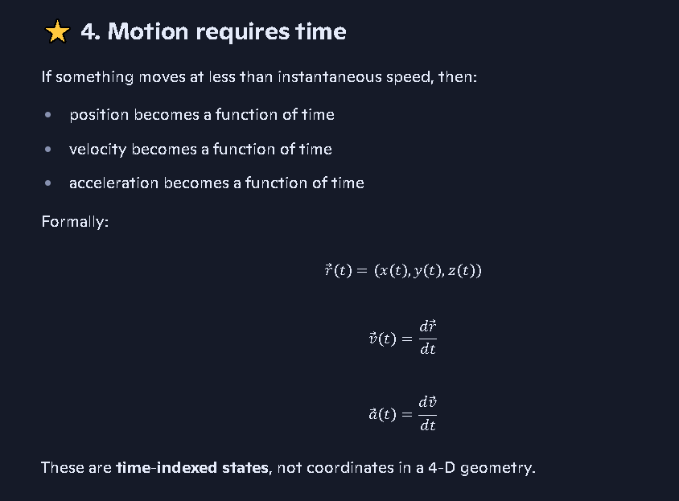
Position, velocity, and acceleration are time-indexed functions, not coordinates in a higher-dimensional geometric space.

P-ST1.2 — Coalition Interpretation
Space is a 3-D invariant container. Time is a 1-D change parameter. They are used together to describe motion, but they remain ontologically independent.
This eliminates the need for Minkowski fusion, curvature of space, or geometric treatment of time.

Ledger-Ready Summary (SIMX Format)
Symbols & Keys (Left Column)
- x,y,z: Spatial axes
- t: Temporal axis
- r: Derived spatial magnitude
- Dimensionality: 3+1
- Anchor: S
- Method: Math/Obs
- Independence Tag: ST-IND
- Motion Functions: r⃗(t),v⃗(t),a⃗(t)
Equation Sets Used (Right Column)
- CV-Spatial-3D
- CV-Temporal-1D
- MX-Motion-Functions
- R#-Dimensional-Independence
- E#-Non-Manifold Constraint
- Δρ/ΔT: Not applicable
- EOS-Crossing: Not applicable
- Notes: r is redundant; no geometric spacetime

